DATA WAREHOUSING AND DATA MINING

DAY 3 PROGRAMS QUESTION QUESTION 1 :

@relation alphabets

@attribute a{true false}

@attribute b{true false}

@attribute c{true false}

@attribute d{true false}

@attribute e{true false}

@data

true false false true true true true true false true true true false true true true false true true true false true true false true false true false true true false false true true false true true true false false true false false true true true true false false true

OUTPUT :

APRIORI ALGORITHM :

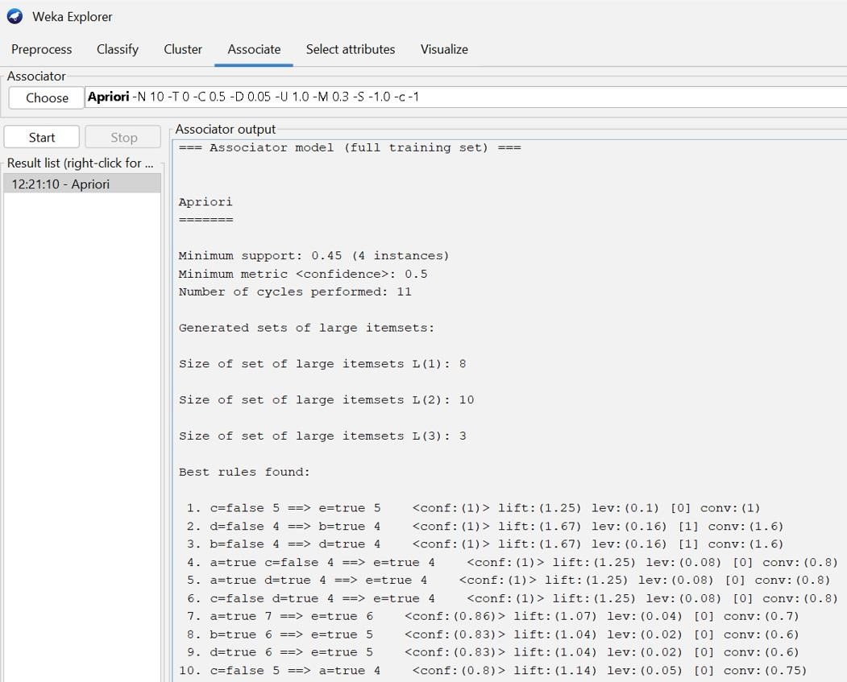

FP GROWTH :

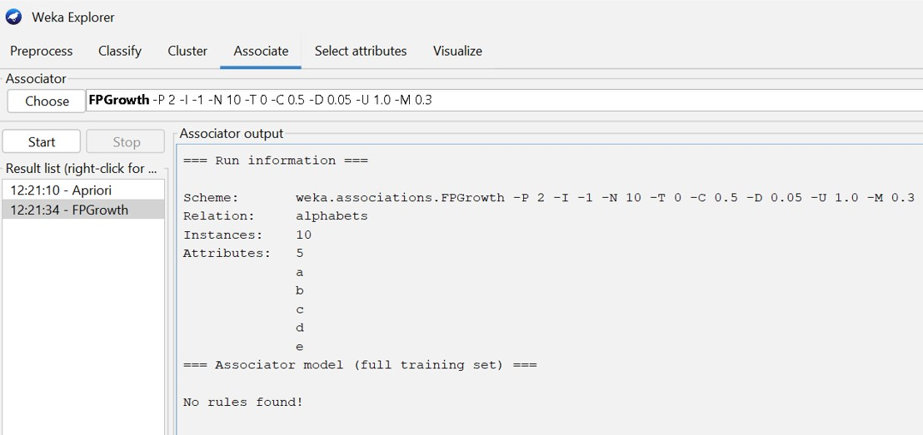

QUESTION 2 :

@relation items

@attribute milk{true false}

@attribute beer{true false}

@attribute diapers{true false}

@attribute bread{true false}

@attribute butter{true false}

@attribute cookies{true false}

@data

true true true false false false true false false true true false true false true false false true false false false true true true false true true false false true true false true true true false false false true true true false false true true false false false true false true true true false false true false false false true

OUTPUT :

APRIORI ALGORITHM :

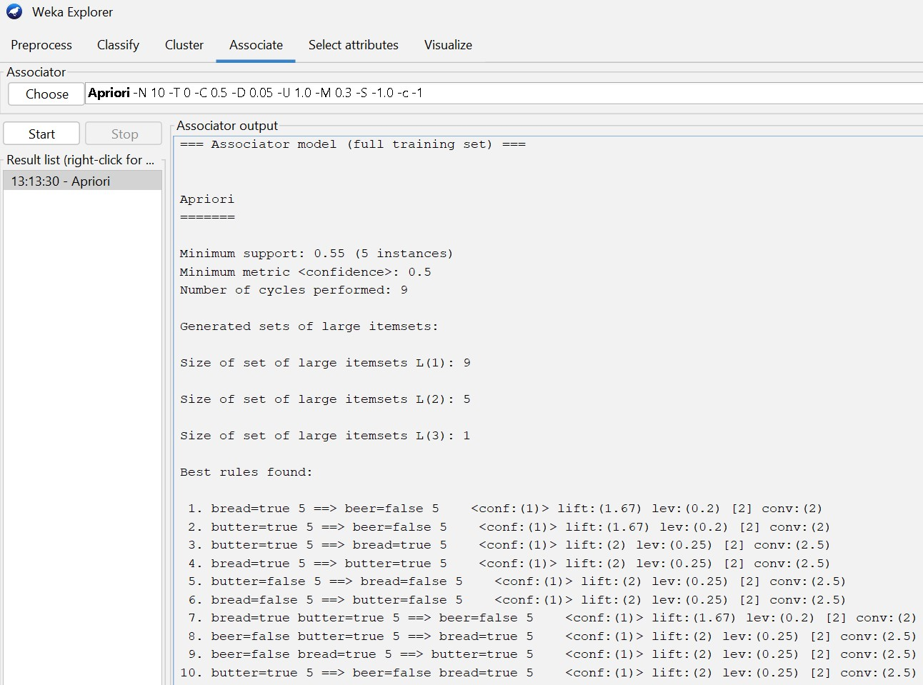

FP GROWTH :

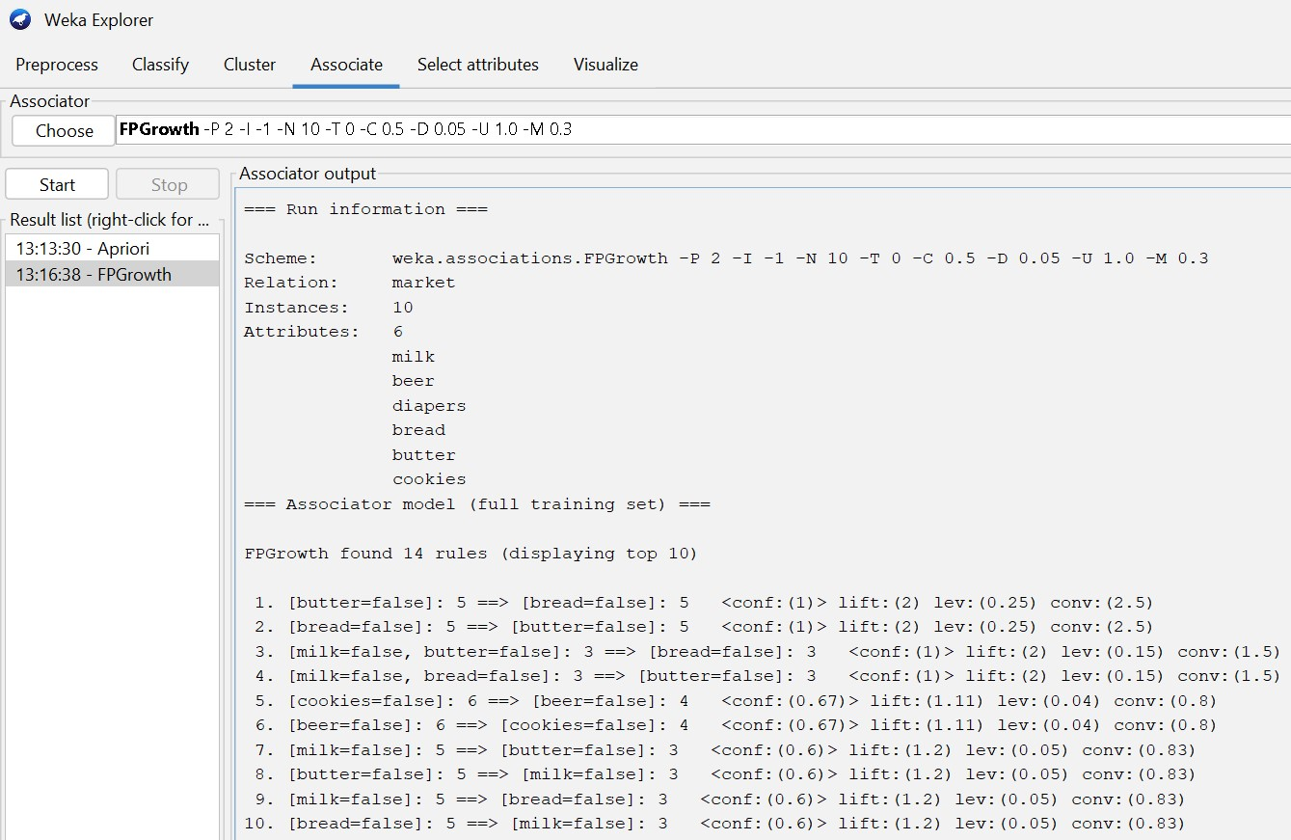

QUESTION 3 :

@relation people

@attribute age{young middle old}

@attribute income{high medium low}

@attribute student{yes no}

@attribute credit_rating{fair excellent}

@attribute buys_computer{yes no}

@data

young high no fair no young high no excellent no middle high no fair yes old medium no fair yes old low yes fair yes old low yes excellent no middle low yes excellent yes young medium no fair no young low yes fair yes old medium yes fair yes young medium yes excellent yes middle medium no excellent yes middle high yes fair yes old medium no excellent no

TRAINING DATA SET :

NAÏVE BAYES :

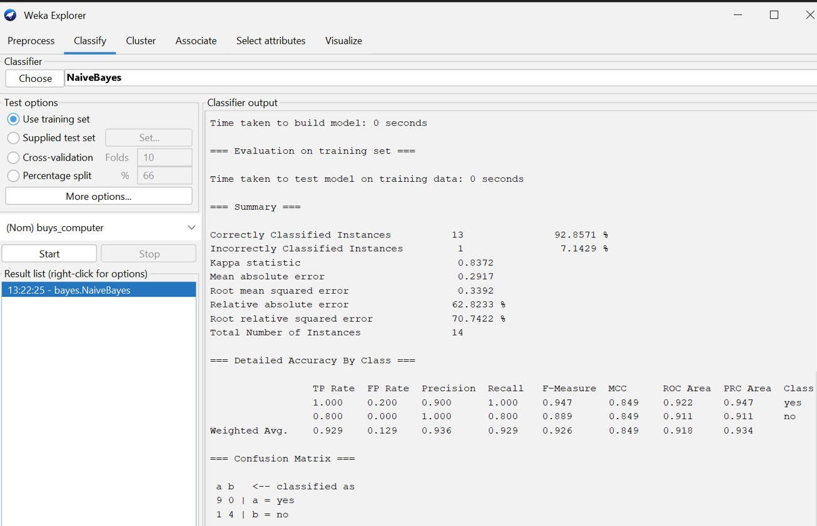

TEST DATA :

@relation people

@attribute age{young middle old}

@attribute income{high medium low}

@attribute student{yes no}

@attribute credit_rating{fair excellent}

@attribute buys_computer{yes no}

@data

young high no fair yes young low no excellent no middle high yes fair yes old medium no fair yes middle low yes fair yes old low yes excellent no

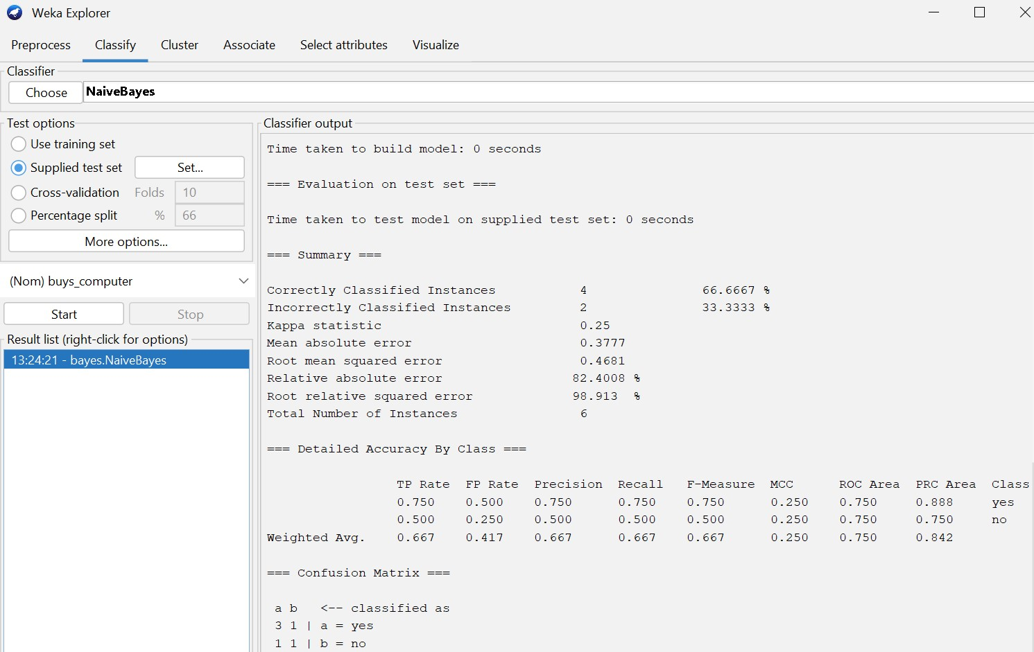

DECISION TREE :

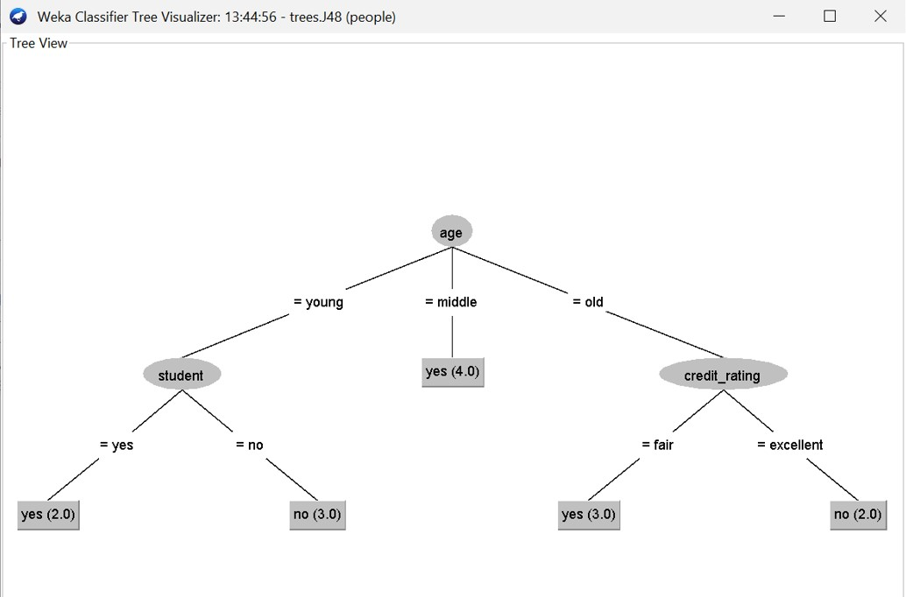

QUESTION 4 :

@relation fp

@attribute m{true false}

@attribute o{true false}

@attribute n{true false}

@attribute k{true false}

@attribute e{true false}

@attribute y{true false}

@attribute d{true false}

@attribute a{true false}

@attribute u{true false}

@attribute c{true false}

@attribute i{true false}

@data

true true true true true true false false false false false false true true true true true true false false false false true false false true true false false true false false false true false false true false true false false true true false false true false true true false false false false true true

OUTPUT :

APRIORI ALGORITHM :

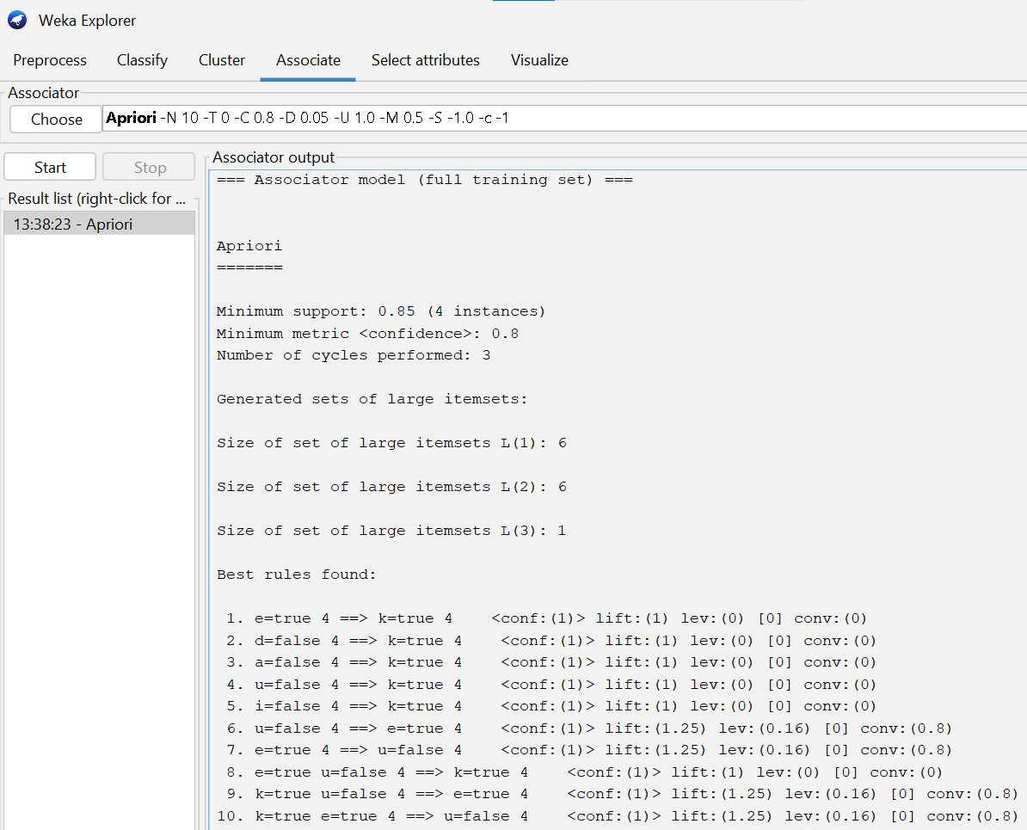

FP GROWTH :

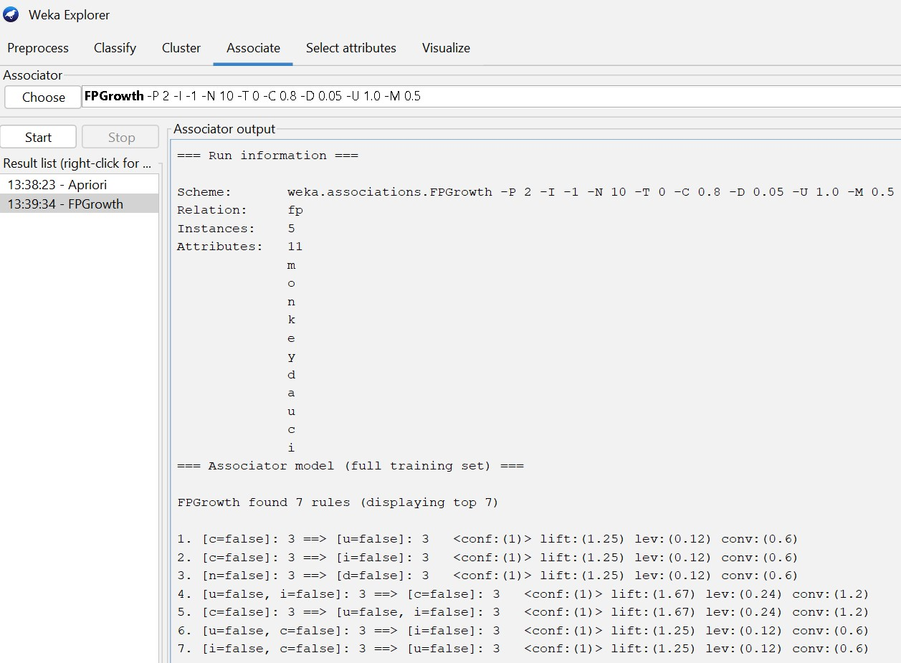

QUESTION 5 :

@relation food_items

@attribute hotdogs{true false}

@attribute buns{true false}

@attribute ketchup{true false}

@attribute coke{true false}

@attribute chips{true false}

@data

true true true false false true true false false false true false false true true false false false true true false false true false true true false false true true

OUTPUT :

APRIORI ALGORITHM :

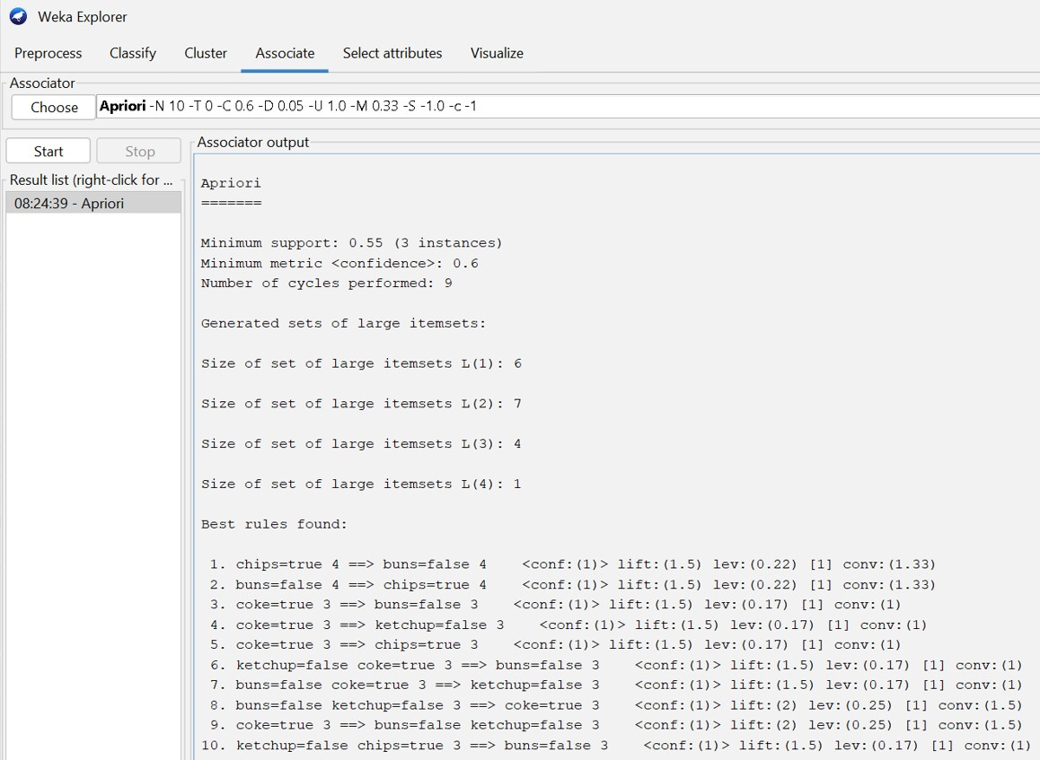

FP GROWTH :

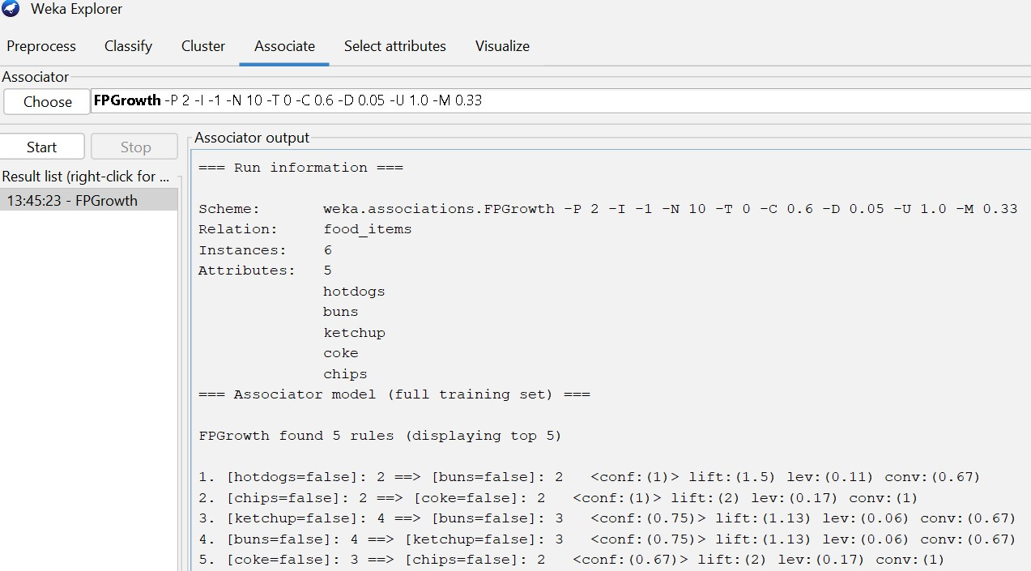

DECISION TREE :

